Bijivemula Reddy Lakshmi
Assistant Professor
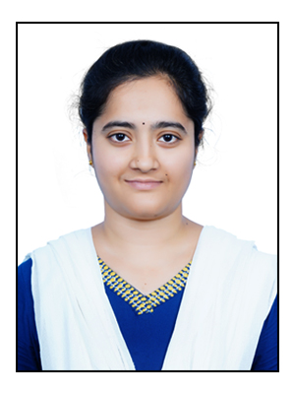
Contact Details : B. Reddy Lakshmi
Assistant Professor
Phone : +91-7337077821
Mail : lakshmibijivemula1999@gmail.com
SBVR Agriculture College, BADVEL, KADAPA

Brief Biography: I’m Assistant Professor with over 6 months of experience in
teaching, sericulture & apiculture.

Responsibilities: Assistant Professor in Entomology
Maintenance of Sericulture & Apiculture

Education : M. Sc. Agriculture in Entomology from Agricultural College, Bapatla (ANGRAU)
(2021-23). Research topic “Biological Activity of Entomopathogenic Actinomycetes against
Fall Armyworm, Spodoptera frugiperda (J.E. Smith) in Sorghum.”
B. Sc. (Hons.) Agriculture from Agricultural College, Mahanandi (ANGRAU)
(2017-2021)
Experience : Assistant Professor, SBVR Agriculture College, Badvel (02/12/2024-Present)
Skills : Experience in Bioassays, culturing of Actinomycetes
Experience in sericulture & Apiculture
Proficient in Microsoft Office
Achievements: Best research paper award from Andhra Agricultural Journal
Participations:
- Poster presentation on “Bioefficacy of Entomopathogenic Actinomycetes against Fall Armyworm, S. frugiperda” in ICPHM 2023 conference.
- Oral presentation on “Screening of actinomycetes against fall armyworm in laboratory” in APGSNC-2023 conference.
LIST OF PUBLICATIONS
Lakshmi, B. R., Kumari, B. R., Rao, S. K., & Gopalakrishnan, S. (2025). Efficacy of secondary metabolites of promising entomopathogenic actinomycetes against fall armyworm, Spodoptera frugiperda (Lepidoptera: Noctuidae). Journal of Biological Control, 39(1), 79-87.
Lakshmi, B. R., Kumari, B. R., Rao, S. K., Gopalakrishnan, S., & Srinivas, V. (2023). Bioassay of Actinomycetes Isolates against Fall Armyworm, Spodoptera frugiperda (JE Smith). Andhra Agricultural Journal, 70(2), 191-196.
B. Reddy Lakshmi
Assistant Professor

